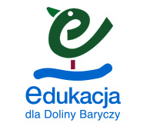
1. Zadanie 1.

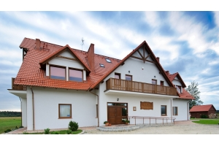
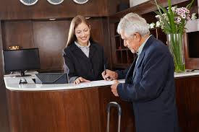

M: Hello!
R: Hello! How can I help you?
M: I / like / to / would / book / a / room.
R: There are single and double rooms. What kind of room would you like?
M: Single room with a bath.
R: How / would / long / stay / like / to / here / you?
M: I’d like to stay here for a week. How / is / much / the / per / night / room?
R: It’s 60 zloty.
M: Are / meals / the / included?
R: Only breakfast.
M: Ok. Thank you.
R: Thank you. Have a nice stay.

2. Zadanie 2.
1. Czy wliczone są posiłki?
2. Jak długo Pan/Pani zamierza tu zostać?
3. Który pokój Pan/Pani wybiera?
4. Chciałbym zarezerwować pokój.
5. Udanego pobytu.
6. Ile kosztuje doba?
7. Mamy pokoje jednoosobowe i dwuosobowe.

3. Zadanie 3.
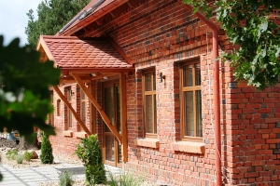

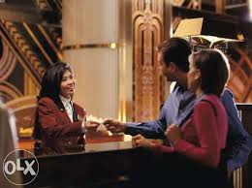

A: Good morning.
B: Good morning. How c…………………………….. I help you?
A: I w…………………… l……………………………… to book a d………………………………. room.
B: With a shower or a bath?
A: A double room with a s……………………………. .
B: How long would you like to s………………………. h…………………………………?
A: Two days. I would like a room with full board.
B: Ok. It will be 200 zloty p………………………………… n……………………………… .
A: Ok. Thank you.
B: T………………………….. y…………………….. .

